Name and Designation  Posting  Permanent address  Ph No.  E-mail: | Dr. Sudhir Kumar Singh  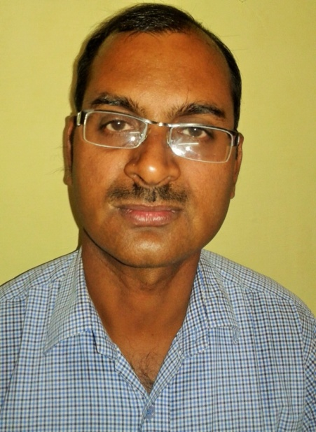  Chief Scientist/ Professor (Plant Pathology)  Centre for Organic and Natural Farming  SKUAST-J, Chatha 180 009  Old Satwari, Street No.6,Hakkal Morh,Chatha, Jammu (J&K)  9419203115(M)  sksinghdr11@skuastj.org
Award | First Poster Award in 2nd International Conference on global Initiatives for Sustainable Development: Issues and Strategies at Hotel Howard Square Boutique, Bangkok, Thialand, June 23-27, 2019. (Co-worker)
Professional experience | 20 years
Selected publications | S.K. Singh,B.K.Sharma,J.S.Srivatava,U.P.Singh and A.B.Ray (1999). Antifungal activity of Alstovenine, a plant alkaloid isolated from Alstonia venenata. Folia Microbiol.44 (5): 510-512  U.P. Singh, S K Singh, B.K. Sharma, J.S. Srivastava B. Prithviraj and Koya Sugawara (2000). Studies on Sclerotium formation in Curvularia species. Mycobiology.29(3): 154-159  D.P.Singh, J.S.Srivastava, Amar Bahadur,U.P.Singh and S K Singh (2004). Arbuscular Mycorrhizal fungi induced biochemical changes in Pea (Pisum sativum) and their effect on powdery mildew (Erysiphe pisi). Journal of Plant Diseases and Protection (Germany), 111(2) 2004,ISSN0340-8159  S.K.Singh, B.S.Jamwal, Bikram Singh and V.B.Singh (2015 ). Screening of host-plant resistance in chickpea (Cicer arietinum) against wilt caused by Fusarium oxysporum f.sp. ciceri. Indian Phytopathology. 68(2):223-225  S.C. Dubey, Birender Singh, OM Gupta, D.R.Saxena, O.P.Sharma, O.D.Kohire,V.P.Anadani, R.K.Singh, S.K.Singh and Aradhika Tripathi (2017). Management of wilt and root rots of chickpea (Cicer arietinum) using Trichoderma harzianum in India. Indian Journal of Agricultural Sciences 87(10):1283-1287.  Reena, M.Sharma, S.K.Singh, B.K.Sinha and A.P.Singh.2020. Earias vitella management by utilizing obnoxious weeds extracts of Jammu and Kashmir Himalayas, India. International Journal of Tropical Insect Science. Published on 16th October,2020  Sharma, M., Chandran, U.S.S., Rani, U., Singh, S. K., Basandrai, A.K., Basandrai, D. 2023. Stability and Suitability of Genotypes and Environment to Ascochyta Blight of Chickpea. Frontiers in Plant Science, Section Plant Pathogen Interactions. DOI 10.3389/fpls.2023.1006099  Kumari,N., Kumar S., Chopra S., Singh, S. K., Sharma, M., Samnotra R.K.and Rani D. 2024. Exploring the role of organic amendments on growth, yield and seed quality of knol-khol (Brassica oleracea var. gongylodes) in northern hills of India. Agriculture Association of Textile Chemical and Critical Review Journal. June:70-76
Research Projects handled/handling:
S.  No. | Name of the project/Scheme | Role (PI/ Co-PI) | Funding Agency | Nature of Project (Societal/ Applied research) | Budget  (Lakh) | Duration with year (From -to)
1. | Composting Technology for Farm Waste Management and Nutrient Recycling | Co-P.I | R.K.V.Y. | Societal | 6.00 | 2018-21
2. | Large scale demonstrations on bio-pesticides for eco-friendly management of high value crops | P.I. | R.K.V.Y. | Societal | 5.36 | 2018-21
3. | International chickpea of Ascochyta blight Nursery | P.I. | ICRISAT, | Applied | 1.00 | 2017 till date
4 | Organic seed production Entrepreneurship in cash crops | Co-P.I. | R.K.V.Y. | Applied | 10.00 | 2018-21
5 | Dissemination of Plant Protection Technologies for Organic Vegetable Production | P.I. | R.K.V.Y. | Applied | 0.80 | 2020-22
6 | Minimizing Pesticides use in Agriculture | P.I. | HADP  J&K Govt | Societal |  | 2022-2027
7 | Alternate Agriculture System for Sustainability | P.I. | HADP  J&K Govt | Societal | 1500.0 | 2022-2027
8 | Technology development and demonstration of organic vegetable cultivation for enhancing soil and human health. | Co-PI | JK DST | Applied | 10.00 | 2024-2026
Number of PG students guided (M.Sc.): | 03
Varieties developed and released(Associated): | 02
Total Research Publications  (Peer reviewed journals) | 35
Conference Proceedings | 07
Technologies generated | 04
Package of Practices | 01
Abstract Books Co-authored | 02
Book chapters | 04
Technical Bulletin | 10
Symposium(Co-organizing Secretary) | 02
Trainings conducted on awareness on application of bio-pesticides in high value and Vegetable crops under RKVY | 08
Certificate course (30 Days) in the capacity of Co-ordinator | 01
Member, J&K Pollution Control (State Level Committee) | 01

(Dr. Sudhir Kumar Singh)

